International Symposium of Green Petrochemical Engineering Innovation Center

Time: 19 Nov. 2018 (Monday, a.m. 9:00-12:00)

Location: South 101, Quangang Building, Qishan Campaus, Fuzhou University

Chairman: Prof. Linxi Hou

Co-chairs: Prof. Jinlin Long

Asso. Prof. Xiancai Jiang

Asso. Prof. Longqiang Xiao

Program

|  |  |  |
| --- | --- | --- |
| Time | Speaker | Title |
| 9:00-10:00 | Prof. Jagadese J. Vittal | My Journey with Crystals under UV Light and beyond |
| 10:00-11:00 | Prof. Donglin Jiang | The Chemistry of Covalent Organic Frameworks |
| 11:00-12:00 | Prof. Qinghua Xu | Plasmon Enhanced Emission and Their Applications |

**My Journey with Crystals under UV Light and beyond**

Jagadese J. Vittal

Department of Chemistry, National University of Singapore, SINGAPORE 117543,

E-mail: chmjjv@nus.edu.sg

The physical and chemical properties of the solids are directly related to their crystal structures. The crystal engineering tools can be used to modify and fine-tune these properties. It is possible to design organic crystals, coordination polymers and metal-organic framework materials with desired physical properties like solubility, crystal bending, guest and gas sorption, storage, separation and transportation, ion exchange, catalysis, magnetism (magnetic ordering, spin crossover), conductivity, optics (multi-photon upconversion, luminescence and sensing, birefringence), negative thermal expansion and processability. As more and more exotic new crystals are made, unexpected, unusual and unpredictable properties have been discovered. In our laboratory we have encountered a number of interesting properties such as structural transformations due to solvent exchange, change of composition and dimensionality due to grinding, unexpected photoreactivity of organic crystals and transition metal complexes and centrosymmetric MOFs showing second-order non-linear optical properties.

Mechanically responsive materials change their shape and size or move in space by light, thermal, pressure or chemical energy. Of these, dynamic molecular crystals undergo various movements like curling, crawling, jumping, leaping, hopping, popping, splitting, wiggling, and exploding, when exposed to heat (thermosalient effect) or light (photosalient effect). These photo-dynamic and thermal-dynamic crystals create new ways of transforming light and heat energy into mechanical work. These effects are similar to popping of mustard seeds on hot oil or corn on hot surfaces. Recently we have also observed such violent popping of single crystals of several metal complexes during the [2+2] cycloaddition reaction under UV light showing the photosalient behavior. In this talk some of these interesting and unusual physical and chemical properties of crystals will be presented.

**The Chemistry of Covalent Organic Frameworks**

**Donglin Jiang**

Department of Chemistry, National University of Singapore, 3 Science Drive 3, Singapore 117543, Singapore

Email: chmjd@nus.edu.sg

Covalent Organic Frameworks (COFs) are a class of crystalline porous polymer that enables the use of pure organic building blocks to build extended polygon architectures and latticed polymer backbones.Recent progress has greatly deepened our understanding of chemistry involved in the design and synthesis of COFs. From a chemistry perspective, COFs have the possibility of engineering predesigned materials with tailor-made structural hierarchy. Importantly, COFs offer an irreplaceable platform for exploring multi-functional materials and molecular systems. Here, we report our approaches to the design, synthesis and functions of COFs by focusing on their unique structure-function correlations observed for both frameworks and channels.1-12

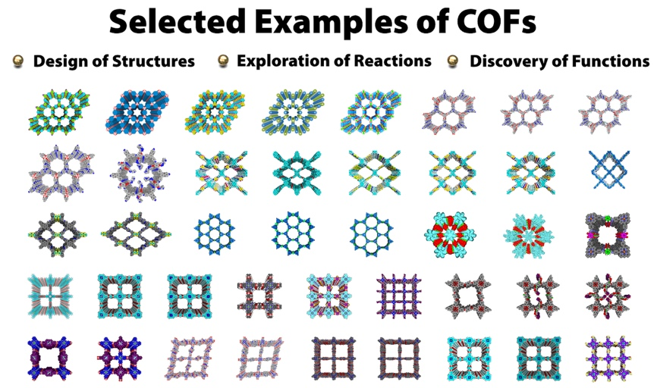

Figure 1. Selected examples of COFs.

**References**

1. Jiang, D. et al. Angew. Chem. Int. Ed. 2008, 47, 8826-8830.
2. Jiang, D. et al. Nat. Chem. 2014, 6, 564.
3. Jiang, D. et al. Nat. Chem. 2015, 9, 905.
4. Jiang, D. et al. Nat. Mater. 2016, 15, 722.
5. Jiang, D. et al. Nat. Rev. Mater. 2016, 1:16068.
6. Jiang, D. et al. Science. 2017, 357, 673.
7. Jiang, D. et al. Nat. Commun. 2018, 9, 4143.
8. Jiang, D. et al. J. Am. Chem. Soc. 2018, 140, 7429-7432.
9. Jiang, D. et al. J. Am. Chem. Soc. 2018, 140, 12374-12377.
10. Jiang, D. et al. Chem. 2019, 5, 1632-1647.
11. Jiang, D. et al. Angew. Chem. Int. Ed. 2019, online DOI: 10.1002/anie.201904291
12. Jiang, D. et al. Angew. Chem. Int. Ed. 2019, online DOI: 10.1002/anie.201909851

**Plasmon Enhanced Emission and Their Applications**

Qing-Hua Xu (徐清华)

Department of Chemistry, National University of Singapore

Abstract: Noble metal nanoparticles (NPs), such as gold (Au) and silver (Ag), display unique properties known as localized surface Plasmon resonance, which could be utilized to enhance linear and nonlinear optical properties of nearby chromophores and metal nanoparticles themselves. In this talk, I will present our group’s efforts on various plasmon enhanced one- and two-photon optical properties and their applications. Aggregated metal nanoparticles were found to display much larger enhancement compared to monodispersed nanoparticles. I will focus on our studies on aggregation induced plasmon coupling enhanced emission of chromophores and aggregation enhanced two-photon photoluminescence of metal NPs from ensemble to single particle measurements. These phenomena have been further utilized to develop various sensing and imaging applications.

About the speaker: XU Qing-Hua (徐清华) received his B.S. from Zhejiang University (1993), M.S. from Peking University (1996) and University of Chicago (1997), Ph.D. from UC Berkeley (2001), and conducted the postdoctoral research at Stanford University and UC Santa Barbara. He joined NUS Chemistry in 2005 and became a tenured associate Professor since 2011. His primary research interest is development of various light based applications such as sensing, imaging, photosensitization and optoelectronics using various low-dimension materials, as well as investigation of the underlying fundamental mechanisms using various novel optical spectroscopy and imaging techniques. So far he has published ~200 peer reviewed articles with citations of >9900 times and H-index of 59.