Field-effect Transistors of Organic Semiconductors

Wenping Hu^{1,2,3}

¹Tianjin Key Laboratory of Molecular Optoelectronic Science, Department of Chemistry, School of Science, Tianjin University & Collaborative Innovation Center of Chemical Science and Engineering (Tianjin), Tianjin 300072, China
²Beijing National Laboratory for Molecular Sciences, Key Laboratory of Organic Solids, Institute of Chemistry, Chinese Academy of Sciences, Beijing 100190, China
³School of Chemistry and Chemical Engineering, University of Chinese Academy of Science, Beijing 100039, China
*E-mail : huwp@tju.edu.cn; huwp@iccas.ac.cn

The fundamental advantages of organic semiconductors have attracted the world’s attention at recent decades and resulted in the rapid development and progress of organic electronics. However, there remain some key challenges in this field such as the low mobility, the not fully understanding structure-properties relationship, the absence of techniques for the fabrication of high performance devices and circuits etc. It is prospective that high-quality single crystals of organic semiconductors could answer these questions and further advance the development of this field. Here, we focuses on organic crystals and field-effect transistors, including the design of new material, the controllable growth of crystals, the structure-properties relationship, and the fabrication of transistors and circuits of organic semiconducting crystals.

Curriculum Vitae
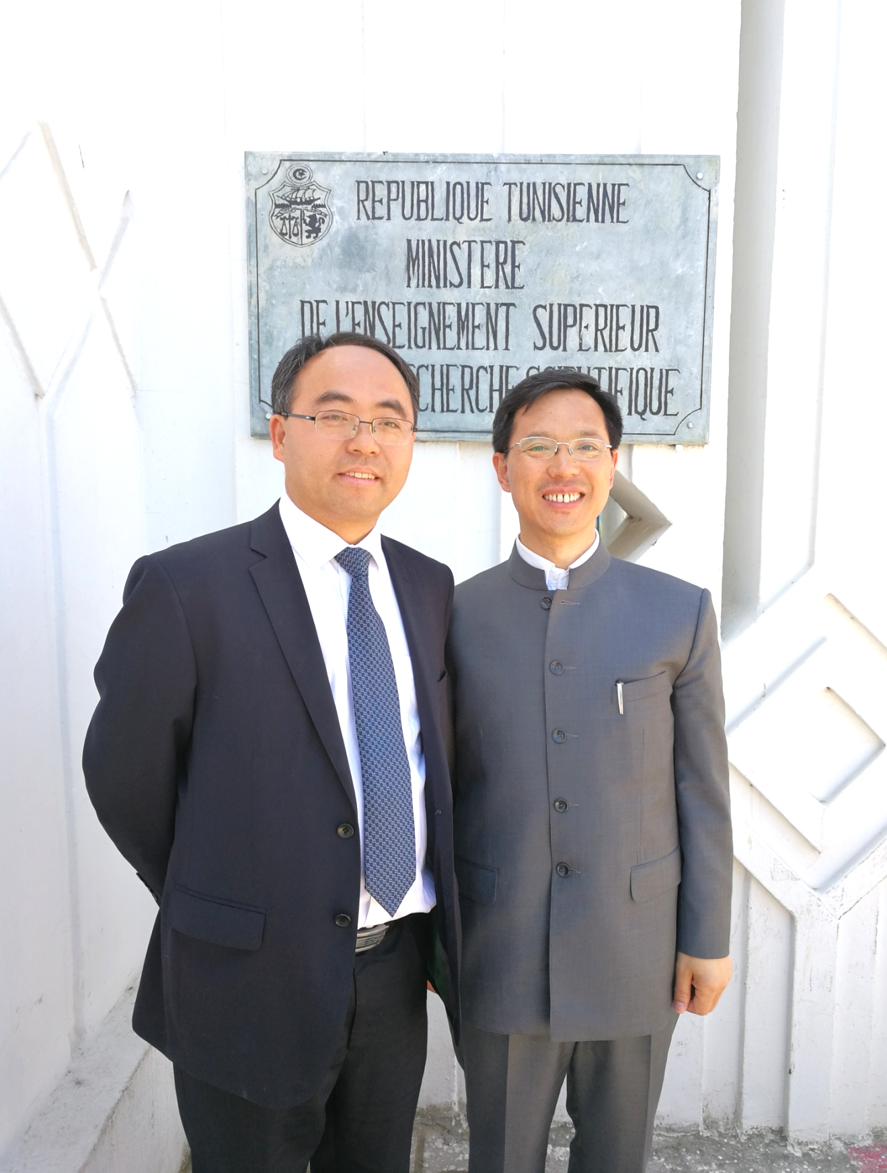
Wenping Hu is a Professor of School of Science, Tianjin University, and a Cheung Kong Professor of Ministry of Education at University of Chinese Academy of Sciences. He received his PhD from the Institute in 1999 (Supervisor: Prof. Daoben Zhu and Prof. Yunqi Liu). Then he joined Osaka University and Stuttgart University as a research fellow of Japan Society for the Promotion of Sciences and Alexander von Humboldt, respectively. In 2003 he worked in Nippon Telephone and Telegraph (NTT), and then joined Institute of Chemistry, Chinese Academy of Sciences, and was promoted to full professor. He shifted to Tianjin University in 2016 and then was promoted to vice president of the university in charge of foreign affairs and science development. He served as a Visiting Scholar at Department of Chemistry, Stanford University in 2007, a Visiting Professor at Department of Chemistry, National University of Singapore in 2013. He focuses on organic optoelectronics. He is a pioneer on the research of organic field-effect transistors in China and organic single crystal electronics in the world. He has published more than 500 peer reviewed papers (IF>10 over 180 papers) with citation of 22,000 times (H index=75). He is a member of the editorial boards for several journals (e.g., Advanced Energy Materials, Advanced Electron Materials, Nano Research, Science China Maters, Science Bulletin, Chemistry-An Asian Journal) and served as an Associate Editor of Polymer Chemistry from 2013-2016.

